

Department of Chemistry

Safety Moment of the Month

**Transporting Chemicals**

**July 2025**

* Use secondary containment when transporting chemicals to a different location (i.e., a bucket with a handle).
* A cart should be used when transporting multiple or heavy containers.
* Do not place incompatible materials in the same container.
* Make sure all chemicals are properly labeled.
* Be mindful of any hazards in case of a spill (have MSDS sheets handy).
* Wear proper PPE for the chemicals being transported.
* Make sure your travel path is clear of any obstacles.
* Carry NMR tubes/samples for analysis in a secondary container (beaker, flask).
* 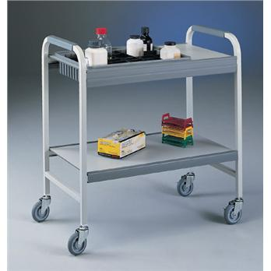Avoid touching doors/door handles on your route while wearing gloves. Ask someone to come along and help open any doors.

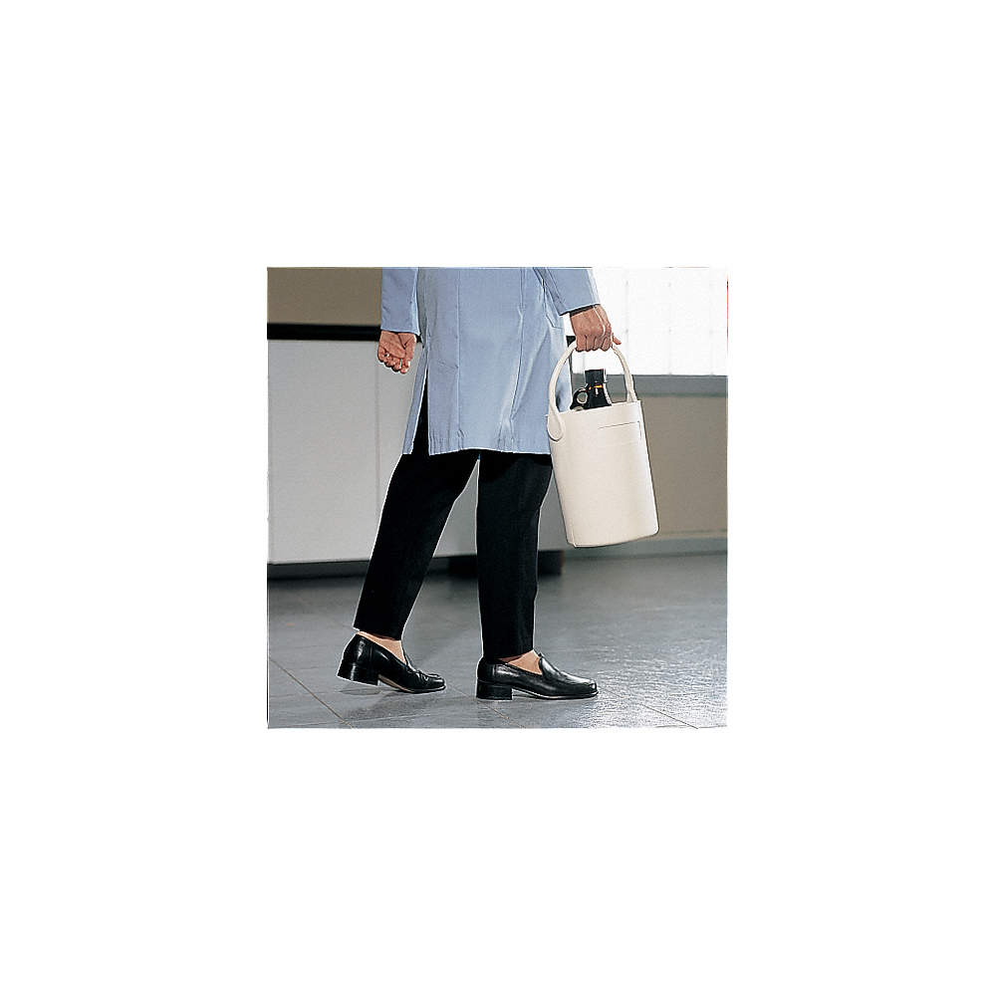

References: <https://safetystoragesystems.co.uk/blog/safe-chemical-transportation/>

Images: <https://www.grainger.com/>